The T&L Neural Network
Testing Examples
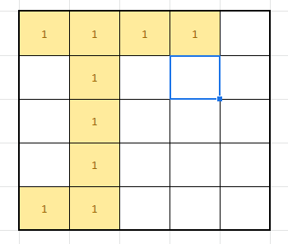

Letter | N1 | N2 | N3 | N4 | N5
T | 5 | 9 | 6 | 2 | 11
Letter | N1 | N2 | N3 | N4 | N5
T | 3 | 5 | 0 | 5 | 7
Letter | N1 | N2 | N3 | N4 | N5
T | 2 | 6 | 4 | 1 | 7
Letter | N1 | N2 | N3 | N4 | N5
L | 2 | 9 | 5 | 1 | 8
Letter | N1 | N2 | N3 | N4 | N5
L | 5 | 5 | 1 | 3 | 0
